
Federal Aviation
Administration

55054002

EN ROUTE

RADAR ASSOCIATE CONTROLLER TRAINING PART B: NONRADAR
Lesson 2: Lateral Separation
Version: 1.0 2022.08

PAGE INTENTIONALLY LEFT BLANK

Lesson Plan Data Sheet

Course Name | En Route Radar Associate Controller Training Part B: Nonradar
Course Number | 55054002
Lesson Title | Lateral Separation
Duration | 1 hour (Includes lesson and ELT)
Version | 1.0 2022.08
Reference(s) | JO 7110.65, Air Traffic Control; JO 7400.2, Procedures for Handling Airspace Matters; FAA Order 8260.3, United States Standard for Terminal Instrument Procedures (TERPS); 14 CFR Part 71, Designation of Class A, B, C, D, and E Airspace Areas; Air Traffic Service Routes and Reporting Points; FAA-H-8083-25B, Pilot’s Handbook of Aeronautical Knowledge
Handout(s) | NONE
Exercise / Activity | NONE
Scenario | NONE
Assessments | YES - Written
Materials and Equipment | Pencil and/or pen
Other Pertinent Information | Ensure lesson materials are downloaded to the classroom computer  This lesson is based on ERAM EAE410  The lesson has been reviewed and reflects current orders and manuals as of April 2022
 As you prep for this lesson, recall and be prepared to talk about examples and personal experiences that illustrate or explain the teaching points in the lesson.

 | Description
 | The Activity icon indicates an exercise, lab, or hands-on activity.
 | The Discussion Question icon signals a discussion question to be asked to the students.
 | The Handout icon indicates a handout is to be distributed to the students.
 | The Instructor Note icon is in hidden text and indicates text that is for the instructor only.
 | The Multimedia icon indicates a video or audio clip is in the presentation.
 | The Phraseology icon indicates that phraseology is in the content.
 | The WBT icon indicates a component of web-based training.
 | The Click icon indicates a PPT slide with click-based functionality to present additional information.
 | The Definition icon indicates a published definition.

PAGE INTENTIONALLY LEFT BLANK

LESSON INTRODUCTION

Overview

1

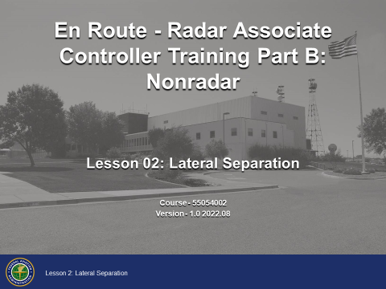

Your proficiency at using lateral separation in conjunction with vertical separation will help resolve traffic situations as they become more complex throughout your training.
This lesson will cover lateral separation and its application in air traffic control situations.

Lesson Objectives

2

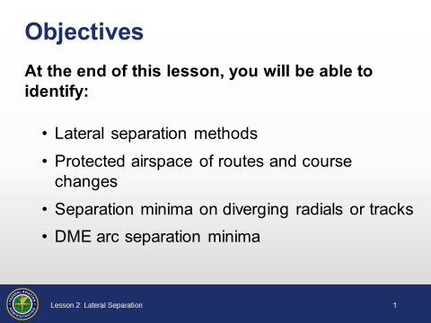

Objectives

- At the end of this lesson, you will be able to identify:
- Lateral separation methods
- Protected airspace of routes and course changes
- Separation minima on diverging radials or tracks
- DME arc separation minima
NOTE: There will be a graded end-of-lesson test upon completion of the lesson. The passing score is 70%. If you do not achieve a score of 70%, you will be provided study time and one retake of an alternate end-of-lesson test.

LATERAL SEPARATION METHODS

Lateral Separation Methods
JO 7110.65, par. 6-5-1

3

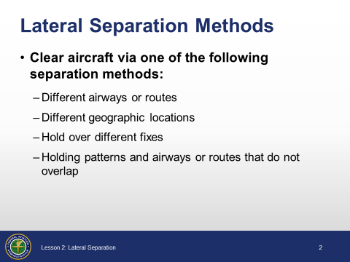

Lateral Separation
- Clear aircraft via one of the following separation methods:
- Different airways or routes
- Different geographic locations
- Hold over different fixes
- Holding patterns and airways or routes that do not overlap

Separation by Different Airways or Routes
JO 7110.65, par. 6-5-1

4

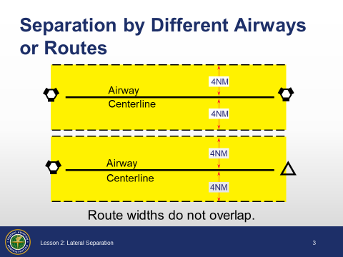

Separation by Different Airways or Routes
- Clear aircraft on different airways or routes whose widths or protected airspace do not overlap

Separation by Geographical Location
JO 7110.65, par. 6-5-1

4

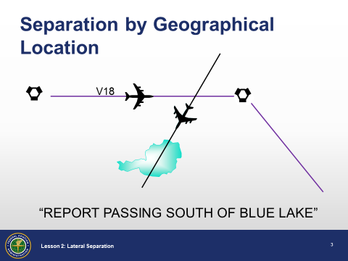

Separation by Geographical Location
- Clear aircraft below 18,000’ to proceed to and report over, or hold at different geographical locations determined:
- Visually
or
- By reference to NAVAIDs

Separation of Holding Patterns
JO 7110.65, par. 6-5-1

5

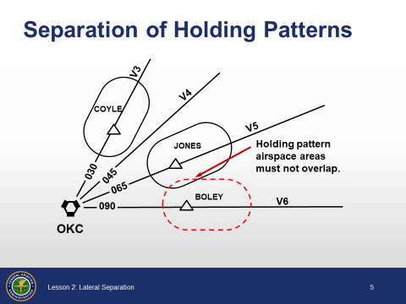

Separation of Holding Patterns
- Clear aircraft to hold over different fixes whose holding pattern airspace areas do not overlap each other, or other protected airspace
- If holding pattern airspace areas overlap, do not hold aircraft at the same altitude

Separation Between Holding Patterns and Airways or Routes
JO 7110.65, par. 6-5-1

6

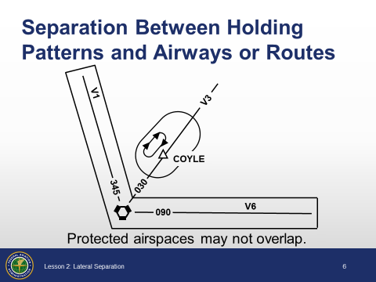

Separation Between Holding Patterns and Airways or Routes
- Clear aircraft to hold at a fix when the protected airspace does not overlap the protected airspace of airways or routes
- If the protected airspaces overlap, do not hold aircraft at the same altitude as aircraft on the airway or route

Effect of Altitude and Speed

FAA Order 8260.3, par. 16-3-3, table 16-3-1

7

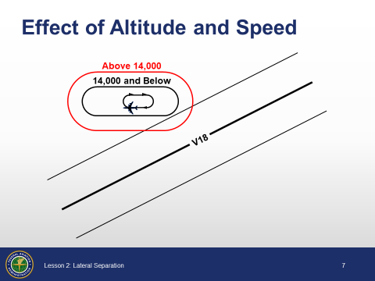

Effect of Altitude and Speed
- Holding pattern protected airspace area increases with greater:
- Altitude
- Speed
NOTE: When holding patterns are designed, the speed and holding altitudes are taken into consideration.

Knowledge Check

8

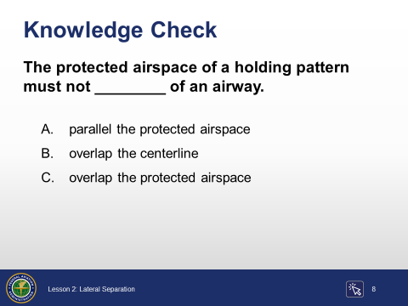

Question: The protected airspace of a holding pattern must not ________ of an airway.

Knowledge Check

9

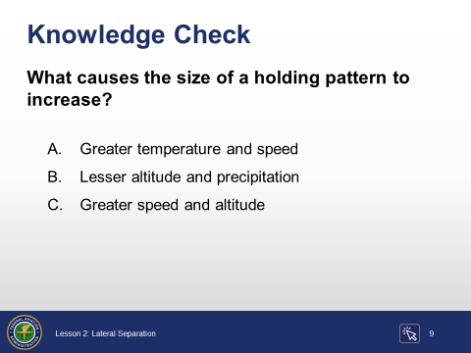

Question: What causes the size of a holding pattern to increase?

PROTECTED AIRSPACE OF ROUTES AND COURSE CHANGES

Established Airways and Routes
FAA Order 8260.3, par. 14-1-2
JO 7400.2, pars. 20-3-3, 20-4-3

10

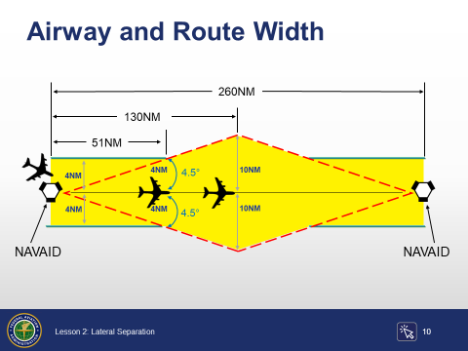

Slide is animated, 2 clicks. Click where indicated by click icon.
Established Airways and Routes
- Protect airspace along established airways or routes as follows:
Click to show the aircraft 51 NM from the NAVAID.
- From 4 miles either side of centerline to 51 miles from NAVAID, then:
- Diverging angle of 4.5° from NAVAID to changeover point
Click to show the aircraft 130NM from the NAVAID.
- No maximum width

Other Than Established Airways or Routes
JO 7110.65, par. 6-5-4

11

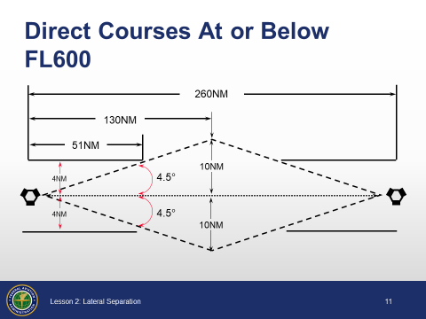

Direct Courses At or Below FL600
- Protect airspace for direct courses and course changes of 15 degrees or less:
- Via NAVAIDs or radials FL600 and below
- 4 miles on each side of the route to a point 51 miles from the NAVAID, then increasing in width on a 4.5-degree angle to a width of 10 miles on each side of the route at a distance of 130 miles from the NAVAID

Degree-Distance Fixes - Military
JO 7110.65, pars. 6-5-4, 4-4-3
12

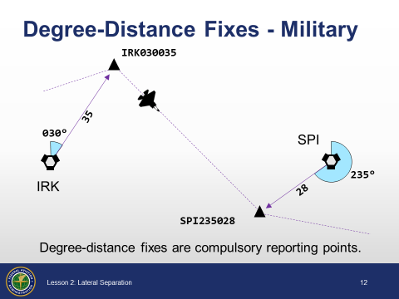

Degree-Distance Fixes - Military
- Protect airspace for direct courses and course changes of 15 degrees or less:
- For aircraft flying via degree-distance fixes that are authorized under Degree-Distance Route Definition for Military Operations
- Below FL180 - 4 miles on each side of the route
- FL180 - FL600 - 10 miles on each side of the route

Degree-Distance Fixes - RNAV Flights
JO 7110.65, pars. 6-5-4, 4-4-3, 5-5-1
12

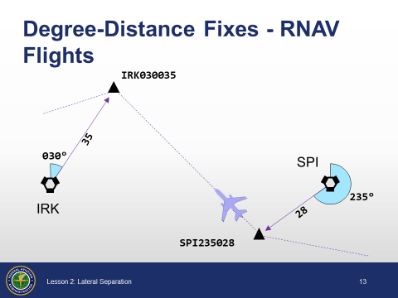

Degree-Distance Fixes - RNAV Flights
- Protect airspace for direct courses and course changes of 15 degrees or less:
- Via degree distance fixes for RNAV flights:
- Above FL450 - 10 miles on each side of the route
NOTE: Radar separation must be applied to all RNAV aircraft operating at and below FL450 on Q routes or random RNAV routes, excluding oceanic airspace. An exception to this is GNSS-equipped aircraft /G, /L, /S, and /V on point-to-point routes, or transitioning between two point-to-point routes via an impromptu route.

GNSS-RNAV Aircraft - Random RNAV Routes
JO 7110.65, par. 6-5-4
13

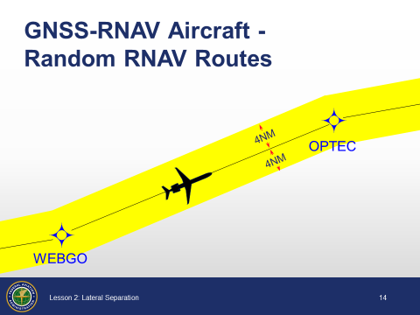

GNSS-RNAV Aircraft - Random RNAV Routes
- Protect airspace for direct courses and course changes of 15 degrees or less
- GNSS-equipped RNAV aircraft provided nonradar separation on random RNAV routes must be cleared via or reported to be established on point-to-point route segments
- Points must be published NAVAIDs, waypoints, fixes, or airports recallable from the aircraft’s navigation database
- Points must be displayed on controller video maps or depicted on the controller chart displayed at the control position
- The maximum distance between points must not exceed 500 miles
- Protect 4 miles either side of the route centerline
- Assigned altitudes must be at or above the highest MIA along the projected route segment being flown, including the protected airspace of that route segment

GNSS-RNAV Aircraft- Transitioning Between Random Routes
JO 7110.65, pars. 6-5-4, 4-4-1
13

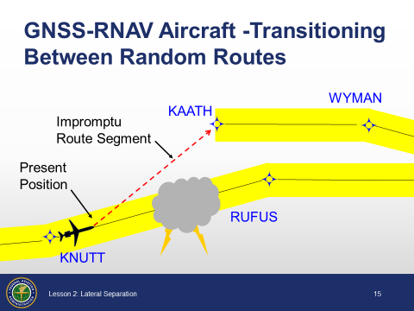

GNSS-RNAV Aircraft - Transitioning Between Random RNAV Routes
- Protect airspace for direct courses and course changes of 15 degrees or less
- GNSS-equipped RNAV aircraft being provided nonradar separation may be cleared via an impromptu route when the following conditions are met:
- The impromptu route segment must not exceed the distance to the nearest available recallable fix/waypoint consistent with the direction of flight; and
- Assigned altitudes must be at or above the highest MIA along the projected route segment being flown; and
- Aircraft conducting the impromptu route must be separated vertically from other aircraft until established on the new point-to-point route
RANDOM IMPROMPTU ROUTE - A direct course initiated by ATC or requested by the pilot during flight. Aircraft are cleared from their present position to a NAVAID, waypoint, fix, or airport.
NOTE: For a random impromptu route, the present position is not a published NAVAID, waypoint, fix, or airport, but is the position at which the aircraft receives the clearance.

Course Changes
JO 7110.65, par. 6-5-4

14

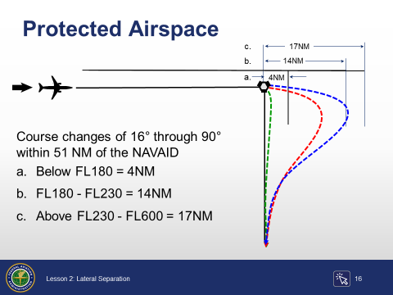

Slide is animated, 3 clicks. Click where indicated by click icon.
Protected Airspace
- Protect airspace for course changes of 16°- 90°
Click to show the overflown side below FL180.
- Below FL180
- 4 miles on each side of the route to a point 51 miles from the NAVAID, then increasing in width on a 4.5-degree angle to a maximum width of 10 miles on each side of the route at a distance of 130 miles from the NAVAID
Click to show the overflown side FL180 - FL230.
- FL180 - FL230
- 14 miles on the overflown side
Click to show the overflown side above FL230.
- Above FL230 - FL600
- 17 miles on the overflown side
- After the course change is completed and the aircraft is back on course, use appropriate direct course minima

Course Changes (Cont’d)
JO 7110.65, par. 6-5-4

15

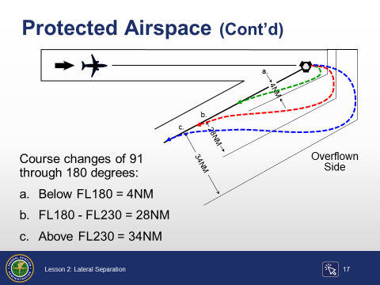

Slide is animated, 3 clicks. Click where indicated by click icon.
- Protect airspace for course changes of 91°- 180°
Click to show the overflown side below FL180.
- Below FL180
- 4 miles on each side of the route to a point 51 miles from the NAVAID, then increasing in width on a 4.5-degree angle to a maximum width of 10 miles on each side of the route
Click to show the overflown side FL180 - FL230.
- FL180 - FL230
- 28 miles on the overflown side
Click to show the overflown side above FL230.
- Above FL230 - FL600
- 34 miles on the overflown side
- After the course change is completed and the aircraft is back on course, use appropriate direct course minima

Knowledge Check

16

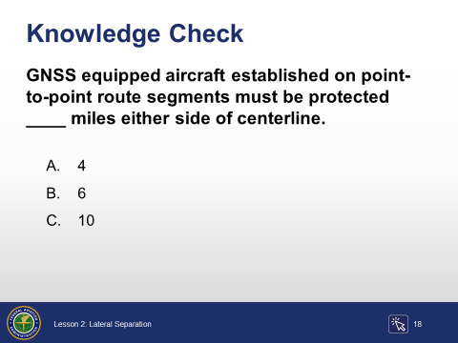

Question: GNSS equiped aircraft established on point-to-point route segments must be protected ____ miles either side of centerline.

Knowledge Check

17

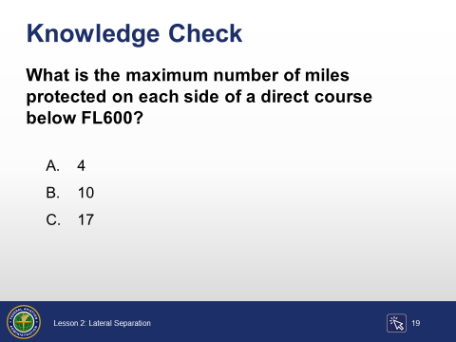

Question: What is the maximum number of miles protected on each side of a direct course below FL600?

Knowledge Check

18

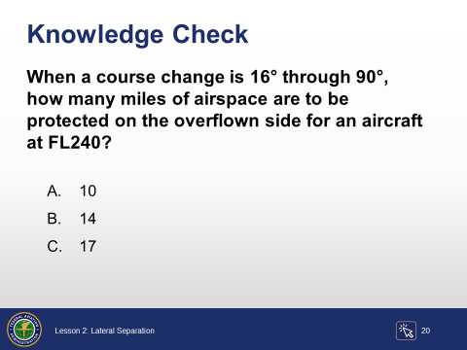

Question: When a course change is 16° through 90°, how many miles of airspace are to be protected on the overflown side for an aircraft at FL240?

Knowledge Check

19

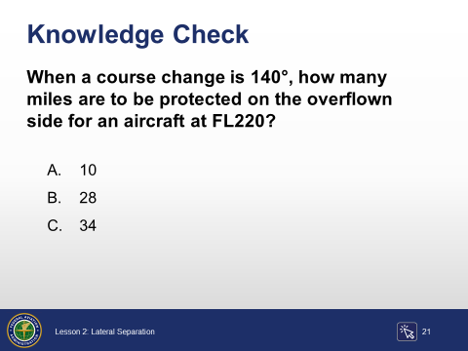

Question: When a course change is 140°, how many miles are to be protected on the overflown side for an aircraft at FL220?

SEPARATION MINIMA ON DIVERGING RADIALS OR TRACKS

Separation Criteria
JO 7110.65, par. 6-5-2

20

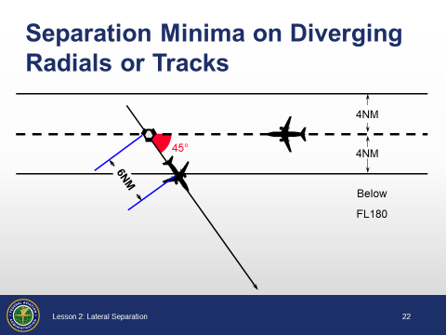

Separation minima on Diverging Radials or Tracks
TRACK - The actual flight path of an aircraft over the surface of the earth.
- Consider separation to exist between aircraft:
- Established on diverging radials of the same NAVAID
- At least 15° divergence when either aircraft is clear of the airspace to be protected for the other aircraft
- With non-VOR/DME based navigational equipment established on diverging tracks of the same waypoint
- At least 15° divergence when either aircraft is clear of the airspace to be protected for the other aircraft

Non-DME Divergence Distance Minima
JO 7110.65, par. 6-5-2, TBL 6-5-1

21

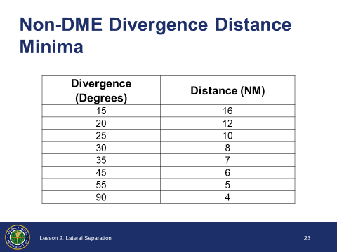

Non-DME Divergence Distance Minima Table
- Used to determine the distance required for angles of divergence to clear protected airspace
- For divergence that falls between two values, use the lesser divergence degree value to obtain the distance
- May be used for aircraft that obtain mileages from sources other than DME, such as LORAN and GNSS, where there is no slant-range error

Non-DME Divergence Distance Minima
Divergence  (Degrees) | Distance (NM)
15 | 16
20 | 12
25 | 10
30 | 8
35 | 7
45 | 6
55 | 5
90 | 4

DME Divergence Distance Minima
JO 7110.65, par. 6-5-2, TBL 6-5-2
FAA-H-8083-25B
22

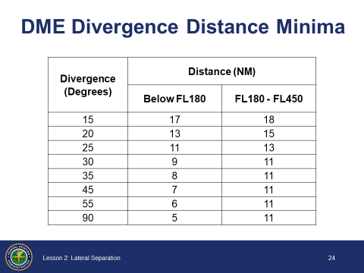

DME Divergence Distance Minima Table
- Used to determine the distance required for angles of divergence to clear protected airspace
- For divergence that falls between two values, use the lesser divergence degree value to obtain the distance
- Compensates for DME slant-range error
SLANT RANGE - The horizontal distance from the aircraft antenna to the ground station, due to line-of-sight transmission of the DME signal.
DME Divergence Distance Minima
Divergence  (Degrees) | Distance (NM)
Divergence  (Degrees) | Below FL180 | FL180 - FL450
15 | 17 | 18
20 | 13 | 15
25 | 11 | 13
30 | 9 | 11
35 | 8 | 11
45 | 7 | 11
55 | 6 | 11
90 | 5 | 11

Knowledge Check

23

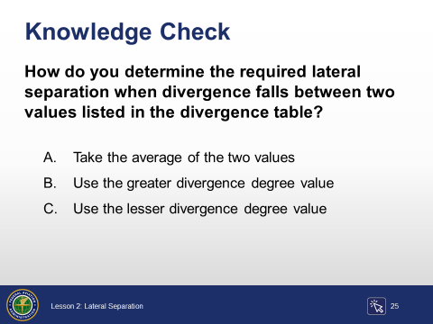

Question: How do you determine the required lateral separation when divergence falls between two values listed in the divergence table?

Knowledge Check

24

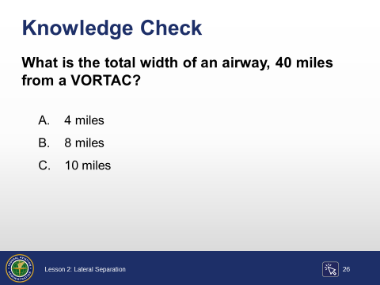

Question: What is the total width of an airway, 40 miles from a VORTAC?

Knowledge Check

25

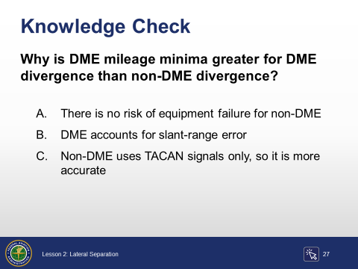

Question: Why is DME mileage minima greater for DME divergence than non-DME divergence?

DME ARC SEPARATION MINIMA

DME Arc Separation Minima
JO 7110.65, par. 6-5-3

26

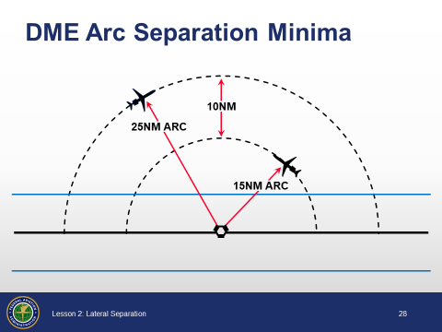

DME arc separation minima
- Apply lateral DME separation by requiring aircraft using DME to fly an arc about a NAVAID at a specified distance using the following minima:
- At 35 miles or less from the NAVAID
- 10 miles
- More than 35 miles from the NAVAID
- 20 miles
- To assign a DME arc:
VIA (number of miles) MILE ARC (direction) OF (name of DME NAVAID)
Example: “N23E CLEARED VIA ONE FIVE MILE ARC NORTH OF THE RED BLUFF VORTAC”

DME ARC - Other Protected Airspace Minima
JO 7110.65, par. 6-5-3

27

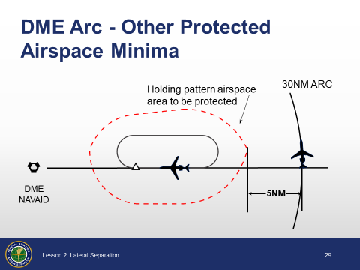

DME Arc - Other Protected Airspace Minima
- DME arc about a NAVAID and other airspace to be protected:
- 35 miles or less from the NAVAID
- 5 miles
- More than 35 miles from the NAVAID
- 10 miles
NOTE: The other airspace to be protected may be a MOA, a holding pattern airspace area, airway or route, ATCAA, warning area, restricted area, prohibited area, etc.

Knowledge Check

28

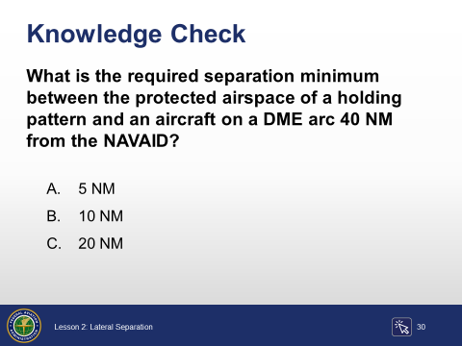

Question: What is the required separation minimum between the protected airspace of a holding pattern and an aircraft on a DME arc 40 NM from the NAVAID?

Knowledge Check

29

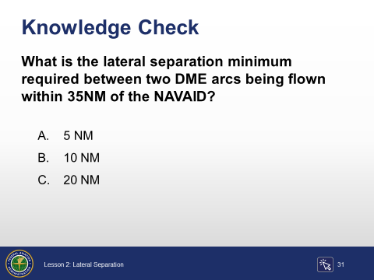

Question: What is the lateral separation minimum required between two DME arcs being flown within 35NM of the NAVAID?

Knowledge Check

30

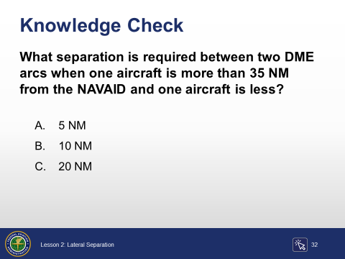

Question: What separation is required between two DME arcs when one aircraft is more than 35 NM miles from the NAVAID and one aircraft is less?

Conclusion

Lesson Summary

31

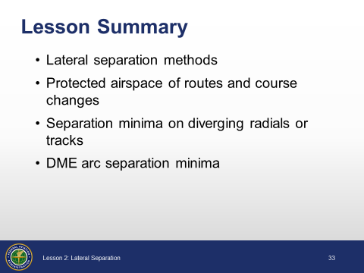

Review and elaborate briefly on the following topics. Ask students if they have questions about any of the concepts covered in the lesson.
Summary
- Lateral separation methods
- Separation by geographical location
- Separation in holding patterns
- Separation between holding patterns and airways/routes
- Departure divergence
- Protected airspace of routes and course changes
- Established airways/routes
- Direct flights at or below FL600
- Degree distance fixes
- Course changes
- Separation minima on diverging radials or tracks
- Divergence distance minima
- Non-DME divergence distance minima
- DME arc separation minima
- Separation of DME arcs
- Minima between an arc and other protected airspace
Hand out and administer the end of lesson test. Provide feedback on missed items, including why particular answers are correct, as well as why some responses are incorrect.

