
Federal Aviation
Administration

55054002
EN ROUTE
RADAR ASSOCIATE CONTROLLER TRAINING PART B:
NONRADAR
Handout 1: Practice Exercises 1, 2, 3
Lesson 1: Longitudinal Separation

Version: 1.0 2022.08

PAGE INTENTIONALLY LEFT BLANK

Practice Exercise 1: Applying 44 or 22 Knot Separation

27

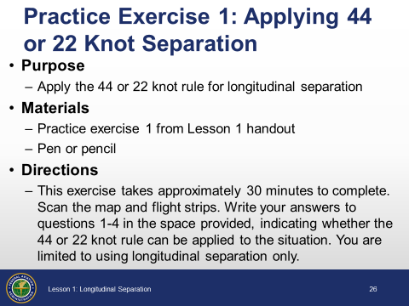

Purpose

Apply the 44 or 22 knot rule for longitudinal separation

Materials
 Handout:
- Practice exercise 1 from Lesson 1 handout
- Pen or pencil

Directions
This exercise takes approximately 30 minutes to complete. Scan the map and flight strips. Write your answers to questions 1-4 in the space provided, indicating whether the 44 or 22 knot rule can be applied to the situation. You are limited to using longitudinal separation only.
 Allow students to complete each question and review the answer before proceeding to the next question. Flight strips are included in PowerPoint presentation.

1.
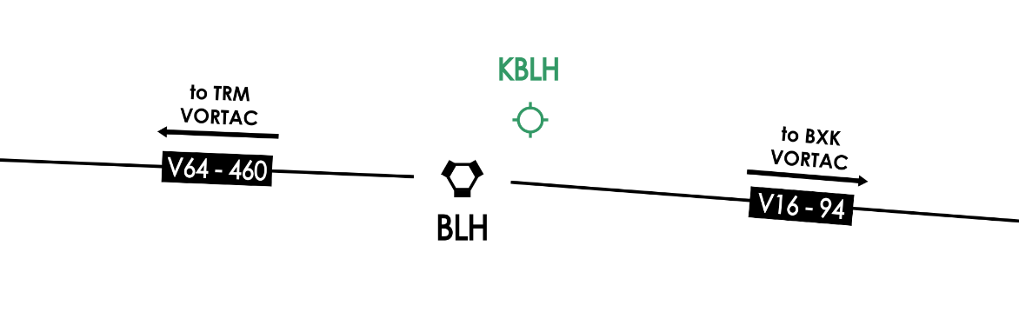
28
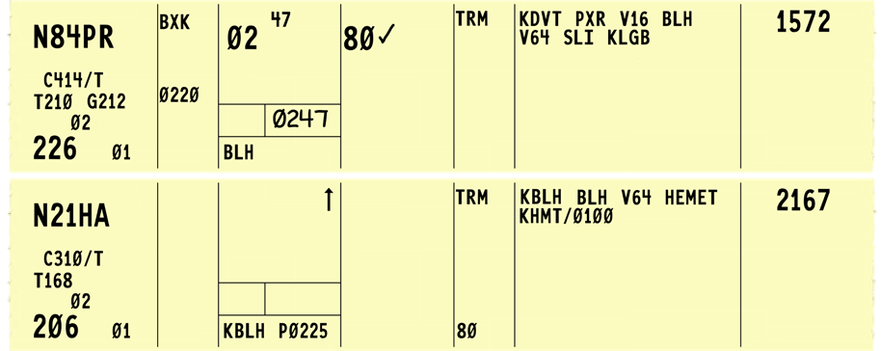

Time is 0248. What is the earliest time N21HA may be released? Explain your answer.

2.
29
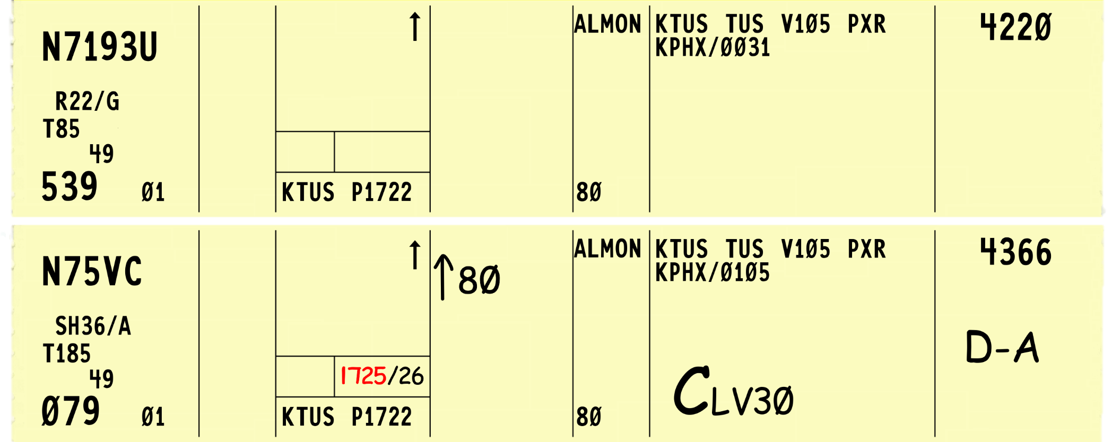

Time is 1726. What is the earliest time N7193U may be released? Explain your answer.

3.
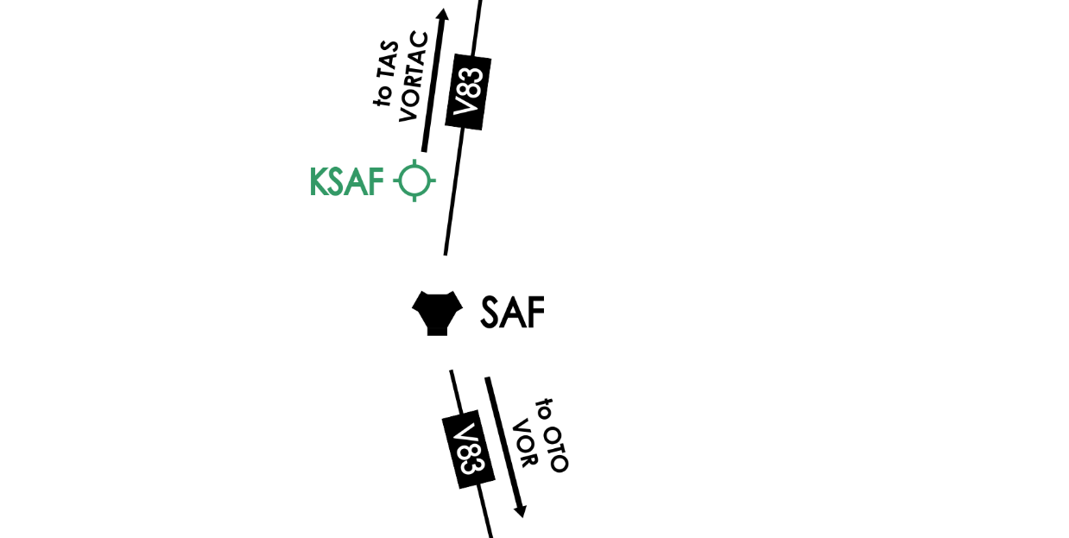
30
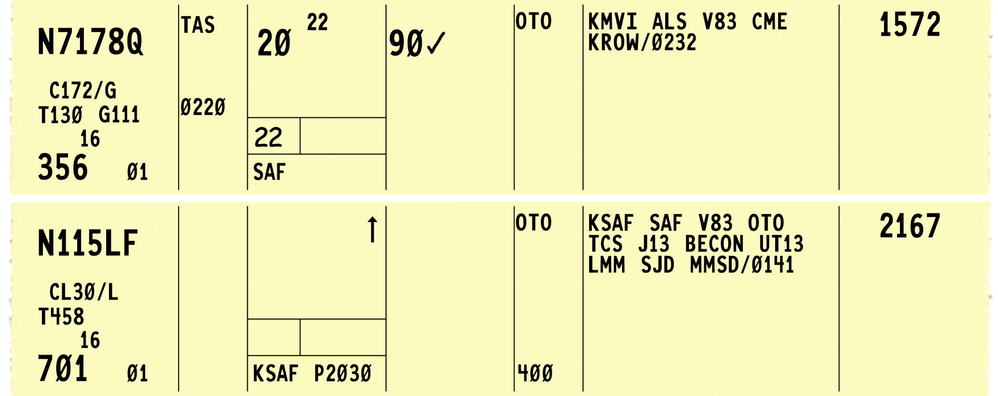

Time is 2023. What is the earliest time N115LF may be released? Explain your answer.

4.
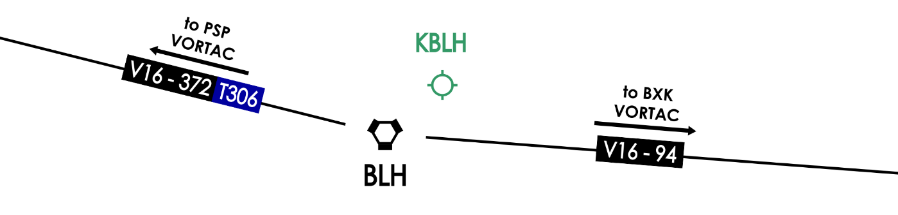
31
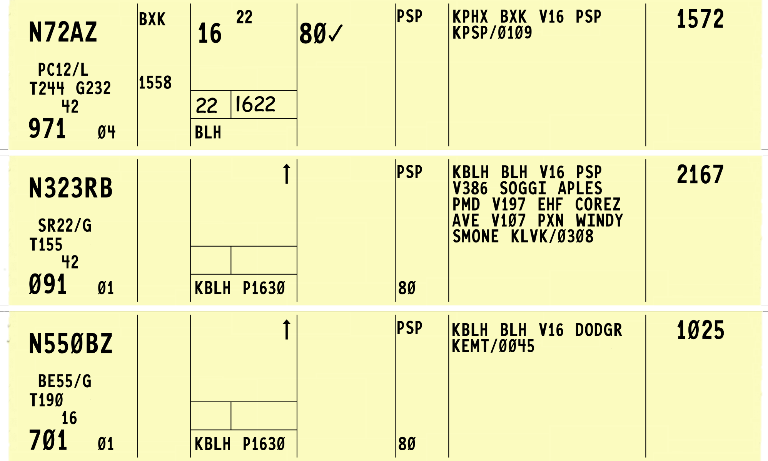

Time is 1625. What is the most efficient order to release N323RB and N550BZ? Explain your answer.

Practice Exercise 2: Applying Same Course Separation
36

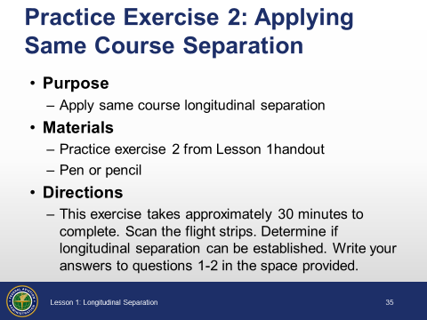

Purpose

Apply same course longitudinal separation

Materials
Handout:
- Practice exercise 2 from Lesson 1 handout
- Pen or pencil

Directions
This exercise takes approximately 30 minutes to complete. Scan the flight strips. Determine if longitudinal separation can be established. Write your answers to questions 1-2 in the space provided.
Allow the students to complete each question and review the correct application of longitudinal separation before proceeding to the next example.
A map will show you aircraft positions for the student queries. PowerPoint slides are available for each flight strip depiction.

1.
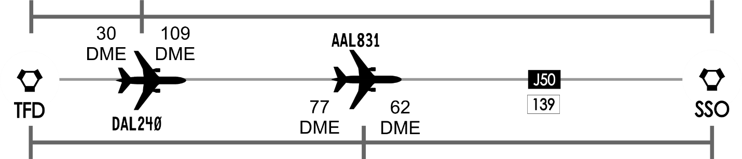
Use the map above to answer requests for DME reports. If there is no response, prompt the students about possible solutions. TFD VORTAC is “Stanfield” and SSO VORTAC is “San Simon.”
37
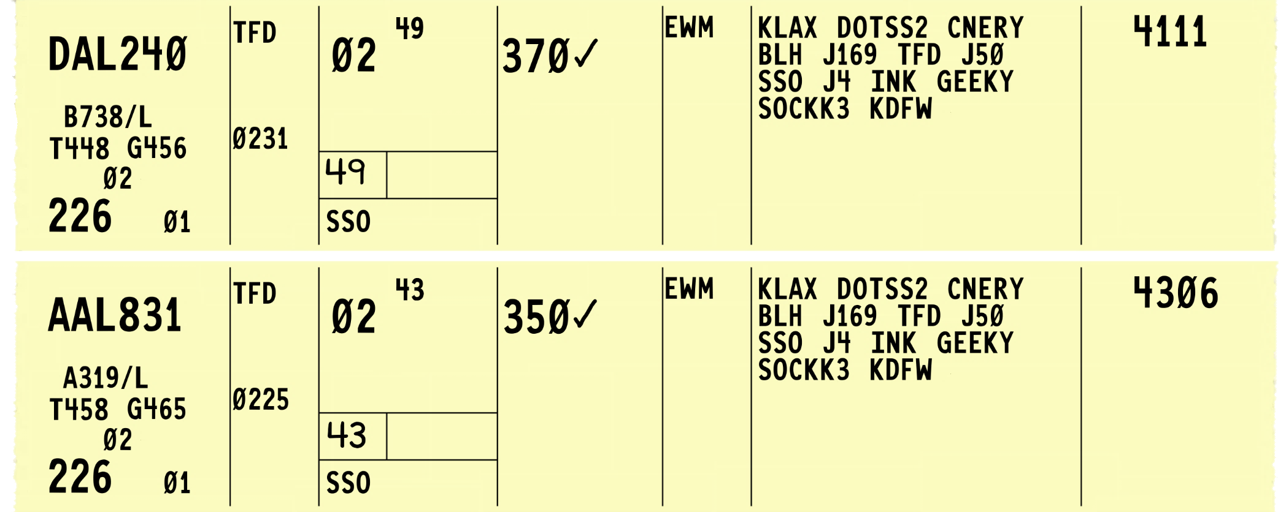
Time is 0235. DAL240 requests a descent to FL330. Indicate what steps you would use and the minima to apply in order to accommodate this request.

2.
38
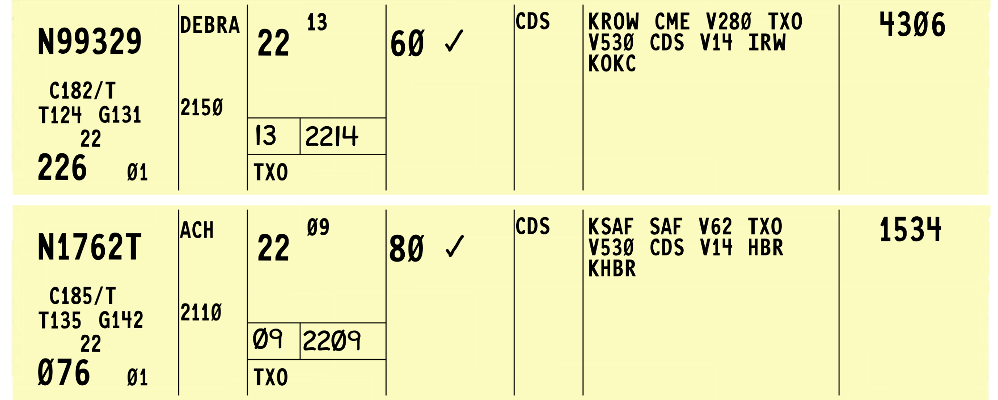
Time is 2221. N99329 is requesting a climb to 10,000’. Can you issue this clearance? Explain your answer.

Practice Exercise 3: Applying Opposite Course Separation

49

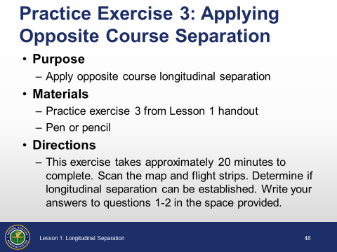

Purpose
Apply opposite course longitudinal separation

Materials
Handout:
- Practice exercise 3 from Lesson 1 handout
- Pen or pencil

Directions
This exercise takes approximately 20 minutes to complete. Scan the map and flight strips. Determine if longitudinal separation can be established. Write your answers to questions 1-2 in the space provided.

Continued on next page
.

1.
50

Use the map above to answer the question on the next.page about discontinuing vertical separation using DME reports. If there is no response, prompt the students about possible solutions. NOTE: BLH VORTAC is “Blythe”.
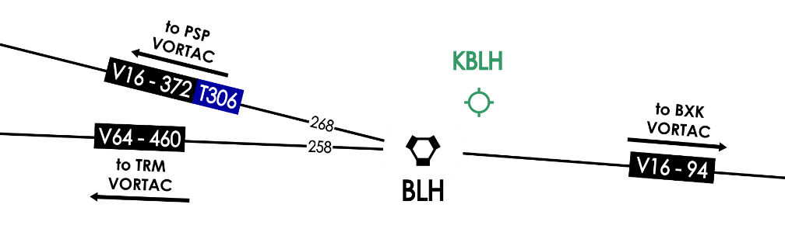

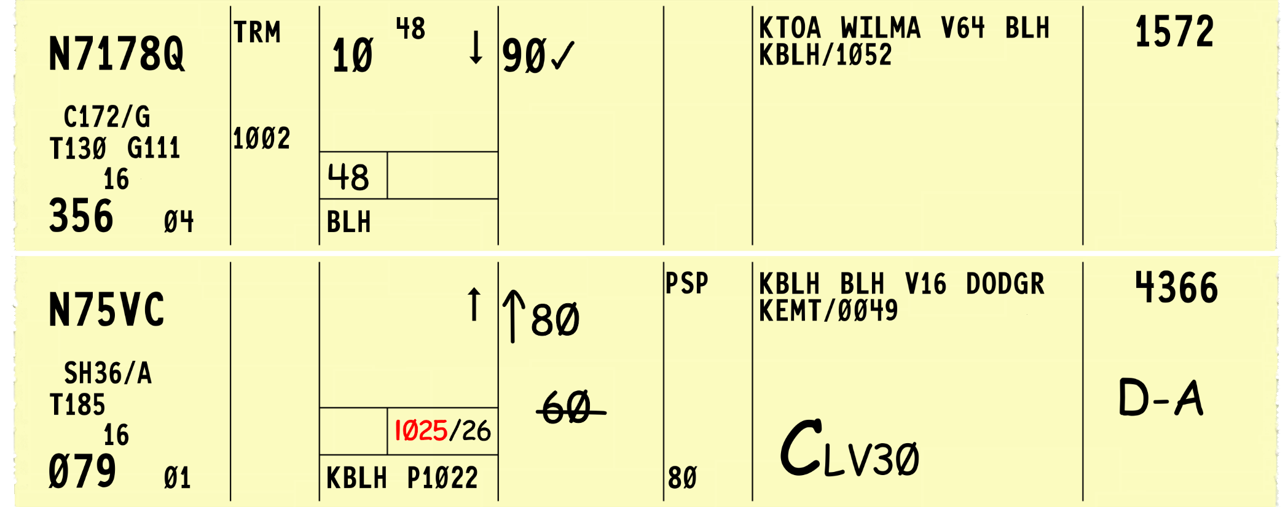
Continued on next page

Time is 1034. N7178Q requests lower. How can you provide separation?

2.
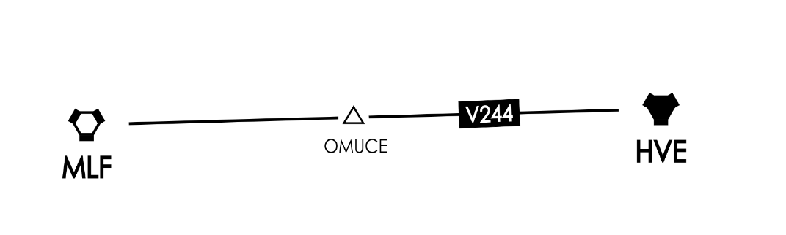

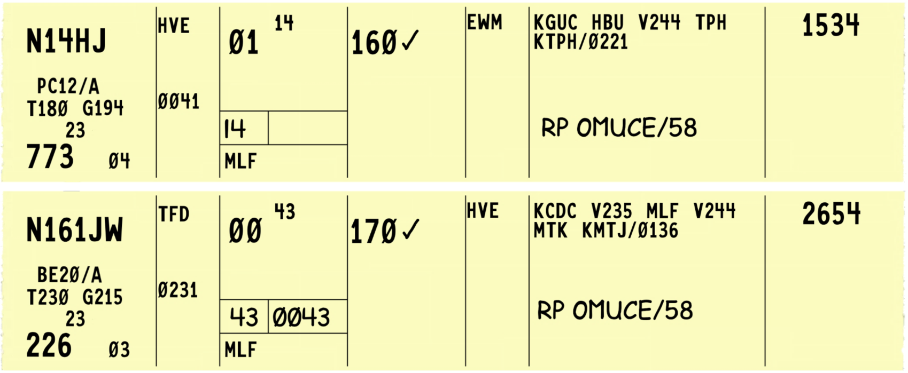
Time is 0058. N161JW is requesting lower. Can you issue the clearance? Explain your answer.

